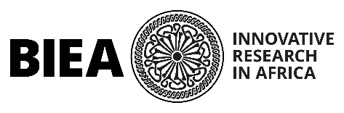

The World of Iron at 10
6th – 11th November 2023
BIEA, Nairobi, Kenya
ABSTRACT SUBMISSION FORM
Completed abstract submission forms* should be submitted by email to iron@biea.ac.uk by 5pm GMT ON FRIDAY 5th MAY 2023. Please note that all information requested on the form should be inserted into the form and should not be submitted as separate documents.
Applicants should use the subject heading ‘Iron {SURNAME OF LEAD AUTHOR}’.
Questions can be directed at any time to iron@biea.ac.uk
Please note:
- Participants should be available to be in Nairobi in-person from 5th – 11th November 2023 inclusive.
- Participants will be expected to submit their papers for publication by summer 2024.
- Participants can lead-author one presentation. Co-authorship is unlimited.

- Name:

- Present position and Institution / organisation:

- Degree(s) with date(s) awarded:

- Email address for correspondence:

- Title of paper:

- Abstract (maximum 500 words):

- Preferred session (please note this cannot be guaranteed and papers will be divided across session by the scientific committee):

- Preferred format (oral / poster presentation):

- Funding. If you have the ability to apply for funding to attend the conference please indicate this here. Please also indicate whether, without full or partial funding you would be unable to attend. There are not sufficient funds available to fully fund, or partially fund all conference participants.

*By completing and submitting this form and so entering into this correspondence, you give consent for BIEA to hold and process your personal data in line with the BIEA Data Management Policy. See www.biea.ac.uk/forms &policies for more details.

